BUS 620 Case Study: Imperfect Competition & Marginal Revenue
Monsanto and the Dynamics of the GMO Seed Market
Established in 1901, Monsanto's evolution spanned from producing saccharin, a sugar substitute, to becoming the world's leader in genetically modified (GMO) seeds. Over its lifetime, Monsanto delved into various markets, from plastics to herbicides, with its introduction of glyphosate-based herbicide “Roundup” in the 1970s marked a significant turn in agricultural practices.

Throughout the years, Monsanto faced several controversies:

1. Patent Enforcement: Monsanto was infamous for its stringent enforcement of intellectual property rights. Farmers were legally prohibited from replanting harvested seeds. This approach compelled farmers to repurchase Monsanto seeds each planting season.
2. Over-reliance on Glyphosate: Due to the promotion of crops that were genetically engineered to resist glyphosate, there was an increasing use of Roundup. This over-reliance led to the evolution of "superweeds" resistant to the herbicide, posing challenges to farmers.
3. Dominance in the GMO Seed Market: Monsanto's immense market share led to concerns of a near-monopoly, especially in the U.S. where they dominated 85% of corn, 90% of soy, and 95% of sugar beets.

The 2018 acquisition of Monsanto by Bayer, the second-largest agrochemical entity globally, for $63 billion further solidified its commanding presence, raising antitrust concerns.

GMO crops, championed by Monsanto, are usually cheaper than their conventional counterparts. Their efficient breeding means lesser resource requirements in terms of land, water, and pesticides. While this translates to potentially higher profits for farmers, it's countered by the need to purchase new seeds annually, whether for crop rotation, better yields, or to avoid patent infringement.

Monsanto's trajectory in the agriculture sector represents the profound impacts, both positive and negative, that large corporations can have on industry practices, economic structures, and societal norms. Their business strategies, combined with technological innovations, have indelibly reshaped global agriculture, posing essential questions about market dynamics, competition, sustainability, and farmers' rights.

Discussion
How did the introduction of GMO corn and Roundup change its business environment?
How about Monsanto’s competitive landscape?

Analysis - The Corn Seed Market

Assumptions:
- Monsanto has fixed costs of $130M associated with its seeds business. (For simplicity, assume this is the same for non-GMO corn seed and GMO)

non-GMO Corn
- The market price for a bag of non-GMO corn seeds is $120.
- Monsanto’s non-GMO corn seed Marginal Cost curve is estimated to be: MC = 0.000029Q
- Monsanto’s non-GMO corn seed Demand curve is estimated to be: D = $120 - 0Q

Given the assumptions above:

- Assuming the non-GMO seed market was a perfect competition market before Monsanto created GMO corn seeds resistant to Roundup:
  - What are Monsanto’s long-run profits associated with non-GMO corn seeds? Create a spreadsheet to calculate:
    - Optimal Output to maximize profits (Perfect Competition: P=MC),
    - Revenue at Optimal Output,
    - Total Costs at Optimal Output,
    - Long-run Profits

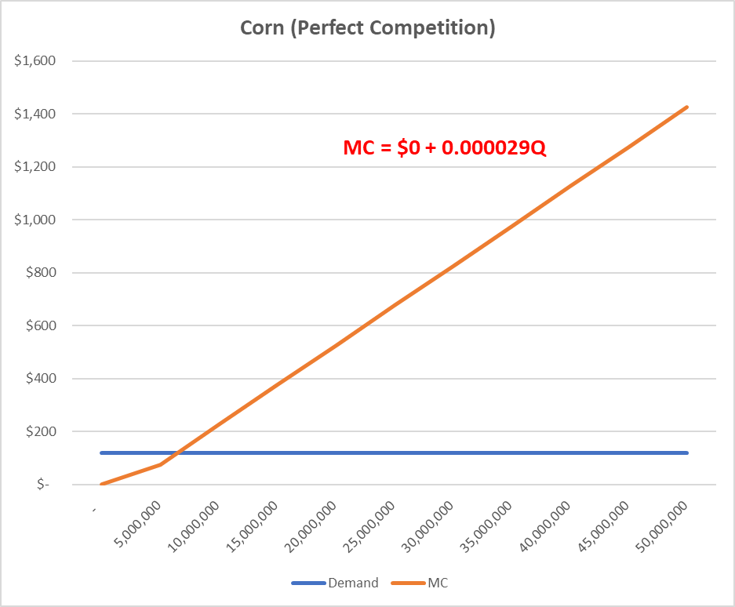

GMO Corn
- Monsanto’s GMO corn seed Marginal Cost curve is estimated to be: MC = 0.00000196Q
- Monsanto’s GMO corn seed Demand curve is estimated to be: D = $525 - 0.0000067Q

- When Monsanto introduced GMO corn seeds resistant to its herbicide Roundup, how did its optimal output change and long-run profits change?
  - Create a spreadsheet to calculate Monsanto’s long-run profits associated with GMO corn seeds as well as:
    - Is this a Perfect or Imperfect Market?
    - What is Monsanto’s Marginal Revenue/MB curve equation?
    - What is the Optimal Output to maximize profits?
    - What is the new equilibrium Price for Monsanto’s GMO corn seeds?
    - Calculate Revenue at Optimal Output & Price,
    - Calculate Total Costs at Optimal Output,
      - What is Monsanto’s Marginal Costs at Optimal?

